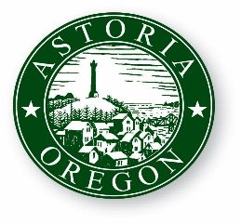
AGENDA

ASTORIA CITY COUNCIL WORK SESSION
WEDNESDAY, JANUARY 10, 2018
9:00 AM
2nd Floor Council Chambers
1095 Duane Street Astoria OR 97103

- CALL TO ORDER

- ROLL CALL

- Downtown on-street parking (public works)

- update on homelessness solutions task force (Astoria police department)

- ADJOURNMENT

